UNIVERSITY OF OTTAWA

FACULTY OF ENGINEERING



SEG 2505: Introduction to Software Engineering

Presented to Dr. Miguel Garzon

Presented by group JH:

Alara OZBIR 7621638

Jean-Marie N’DAH 7350840

Edgard SIA 7952575

Hassan MOKDAD 7332941

Ludny Lemi CICERON 7962403

**1) Introduction** **2**

**2) Updated UML Class Diagram** **3**

**3)** **Task Allocations 4**

**4) Screenshots of the App** **5**

4.2) Login Page 6

4.2) Admin - Welcome Page and Create a new service 7

4.3) Admin - Delete/Edit Services 7

4.4) Service Provider - Welcome Page and Set Availabilities 8

4.5) Service Provider - Associate the profile with one or multiple service 9

4.6) Service Provider - Modify availabilities 10

4.7) Home Owners - Welcome Page & Search By 11

4.8) Home Owners - Book Service & Feedback 12

**5) Lessons Learned** **13**

# 1) Introduction

The main goal of this project was to offer the students the opportunity to hone the skills acquire in class and develop a service control mobile application. The application was developed in order to accommodate three different types of user, namely administrators, service providers and homeowners. In the application, administrators are able to create services, as well as updating and deleting the created services. The Service providers are able to create their profile with information regarding their profession and expertise. Once their profile information entered, they are able to add and delete the created services to their profile and enter their availability as well as edit them. Homeowners, on their hand, are able to search for service providers based on three separate criteria, by service, by rating and by availability. Once the homeowner books the service provider, he can rate the service by leaving a comment and a rate out of 5.

This report will contain the final UML class Diagram, a table stating the different contribution of each member of the team, screenshots of the different pages of the application and finally the different lessons learned during this wonderful experience.

# 2) Update UML Class Diagram

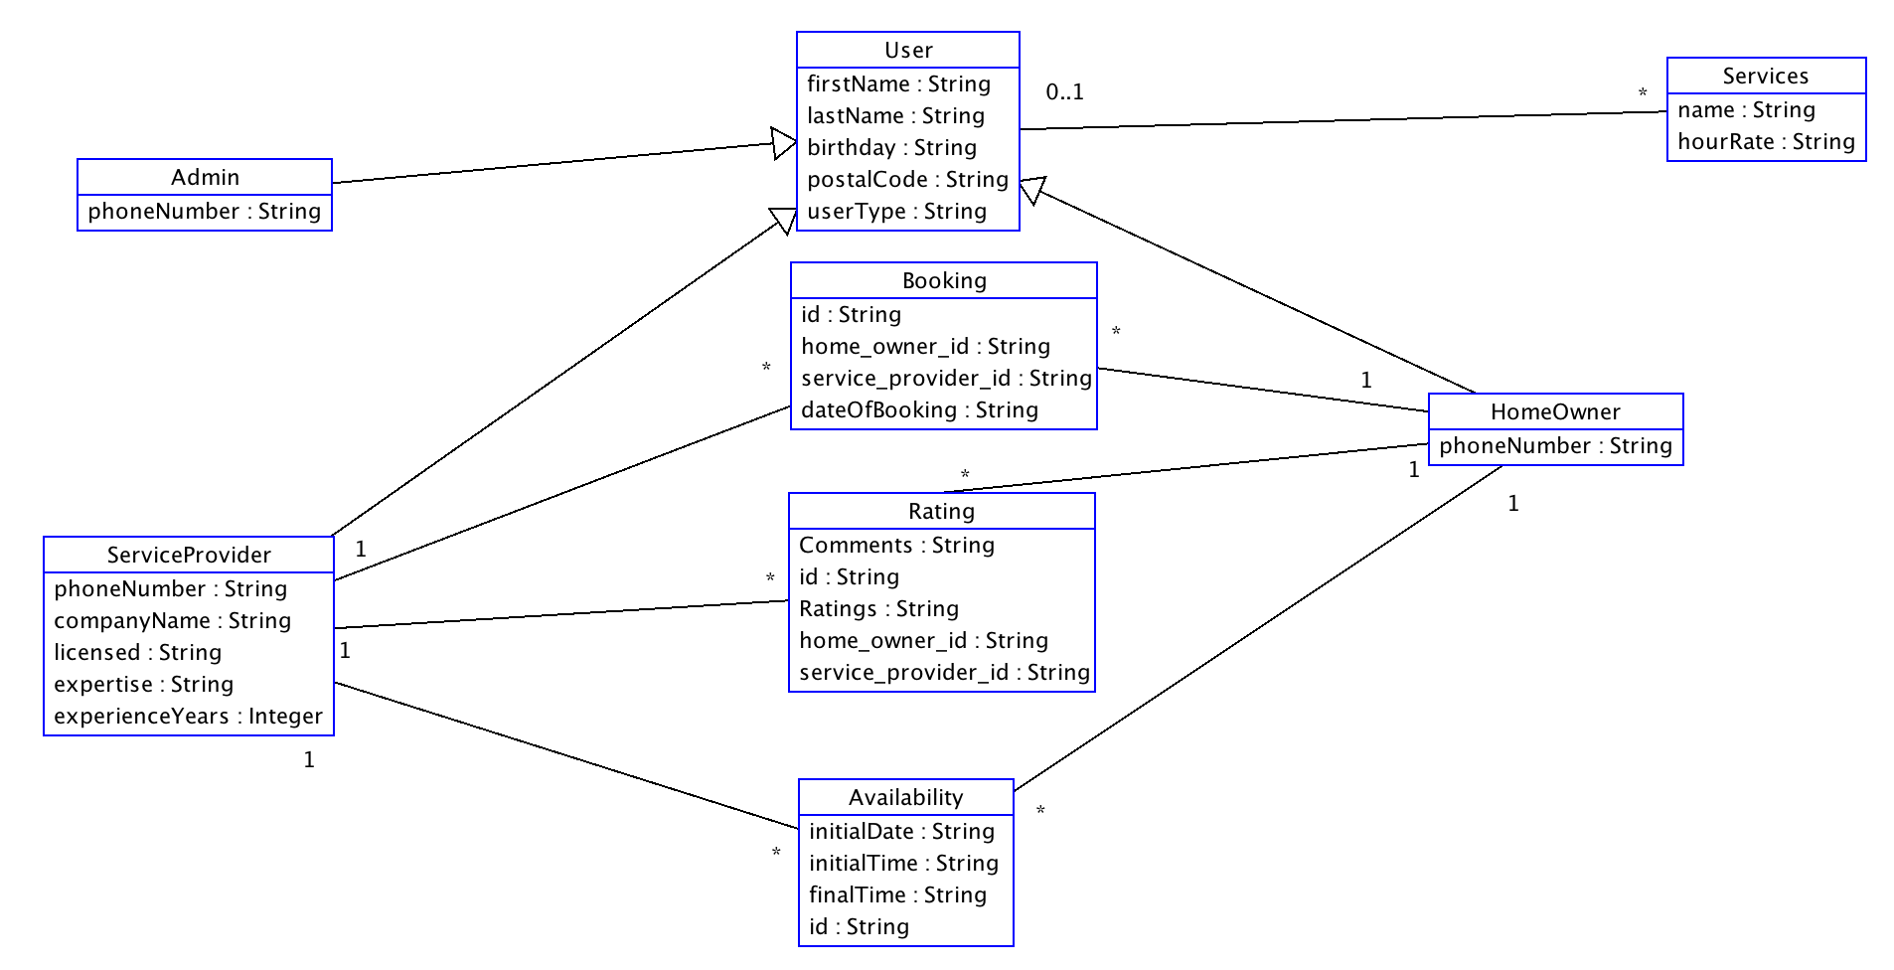

**Figure 1. Final UML class diagram.**

# 3) Task allocations

|  |  |  |  |  |
| --- | --- | --- | --- | --- |
|  | Deliverable 1 | Deliverable 2 | Deliverable 3 | Deliverable 4 |
| Jean-Marie | Database Creating, Logic between the two pages | Database Management,  Update and Delete services for Admin | Database Management,  Login page,  Service provider enters availability | Database Management,  Functional testing and fixed the last bugs |
| Hassan | UML diagram, functional test | UML diagram, functional test | UML diagram and functional testing | UML diagram, functional testing and unit test |
| Alara & Ludny | Validate the field | Unit tests | Service provider, Add/Delete services | Report, presentation, search by rating, feedback on service booked, unit tests |
| Edgard | Main activity  Spinner to create the different accounts | Admin account user interface. All field validated to create a service. | Can complete the profile information. | Search by service and Time |

# 4) Screenshots of the App

## 4.1) Admin/Homeowner and Service provider Account creation.

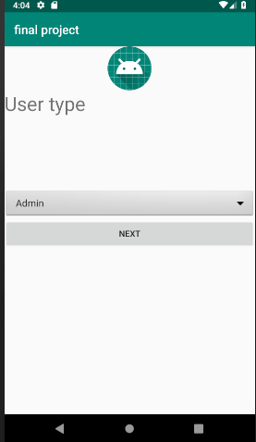 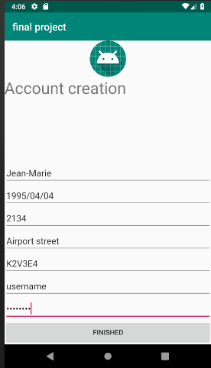

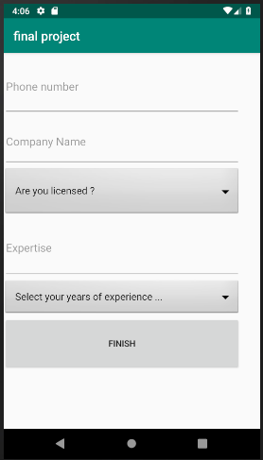 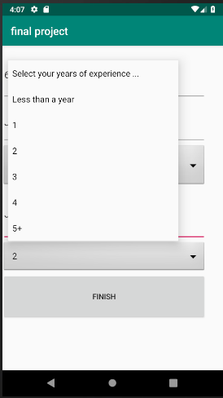

## 4.2) Admin - Welcome Page and Create a new service

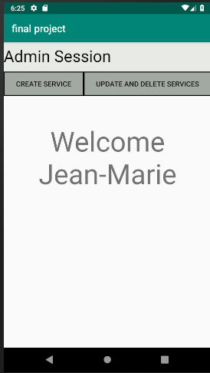 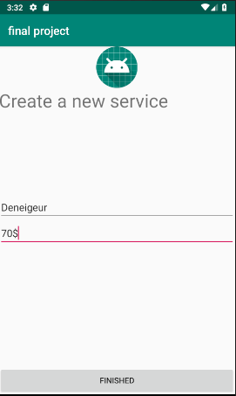 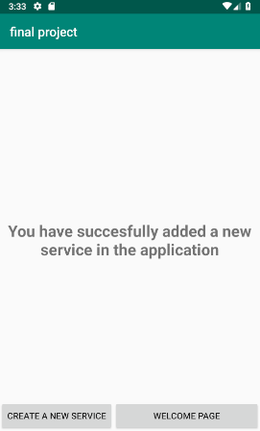

## 4.3) Admin - Delete/Edit Services

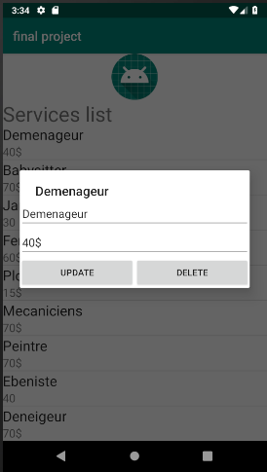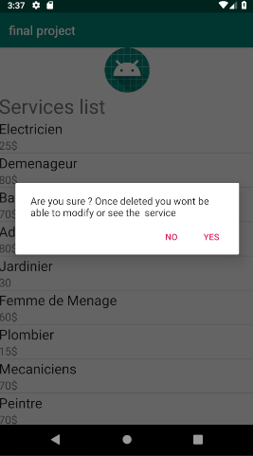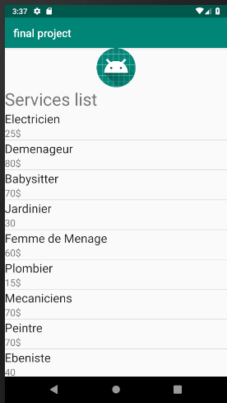

## 4.4) Service Provider - Welcome Page and Add Availabilities

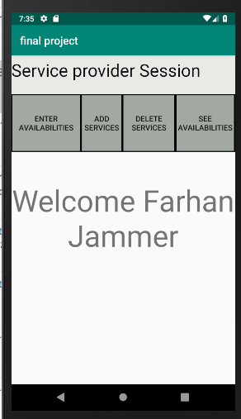 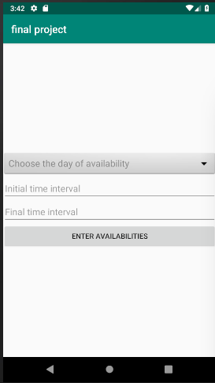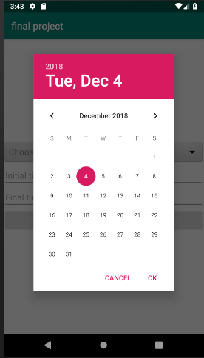 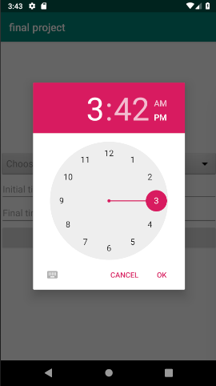

## 4.5) Service Provider - Associate the profile with one or multiple service

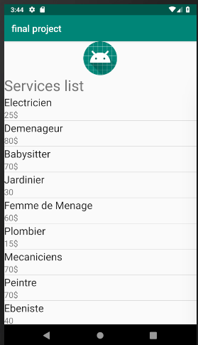 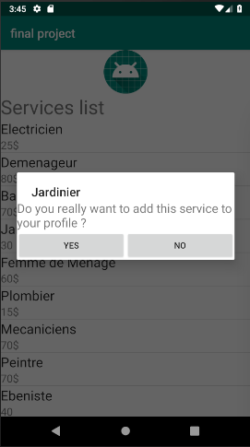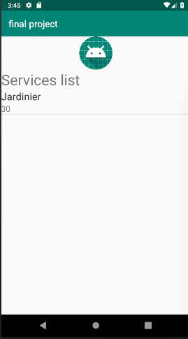 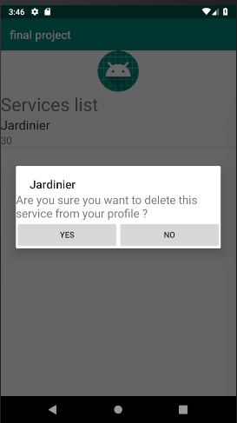

## 4.6) Service Provider - Modify availability

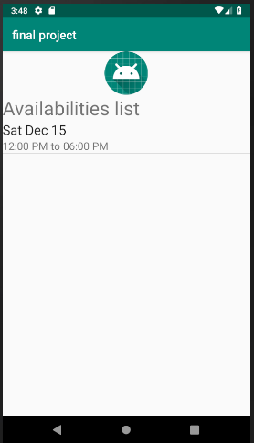 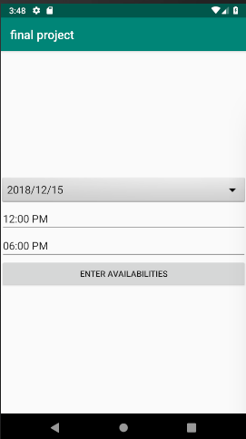 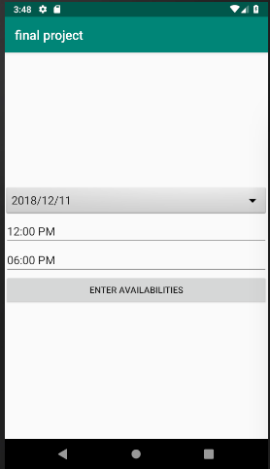 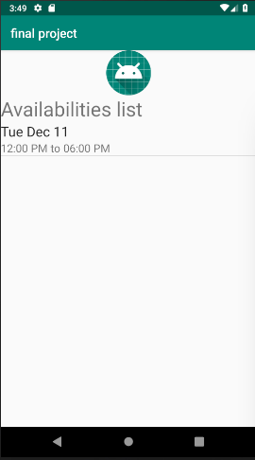

## 4.7) Service Provider–Delete services

 



## 4.8) Home Owners - Welcome Page & Search By service

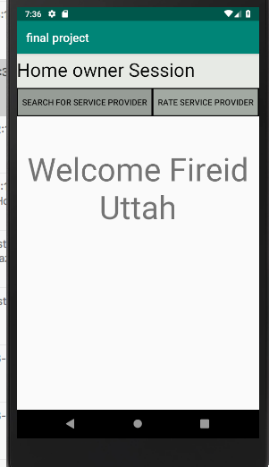 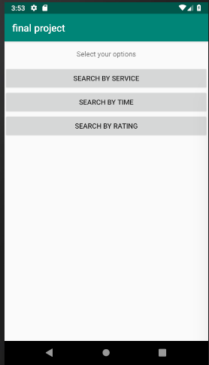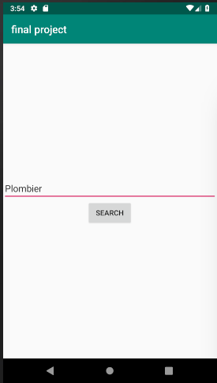 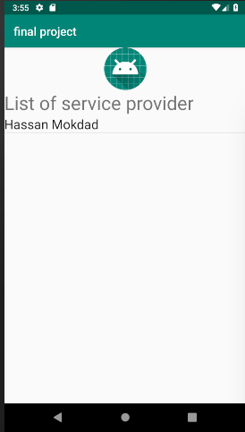

## 

## 

## 4.9) Home Owners - Search by Rating

 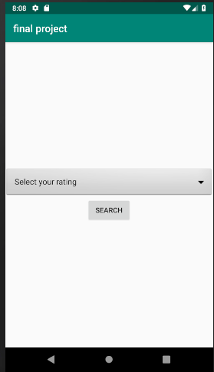

 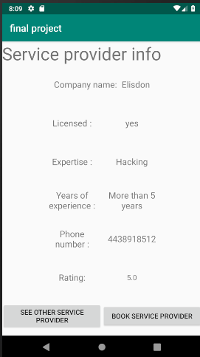

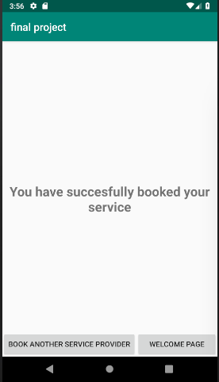

## 4.10) Home Owners - Search by Time

  

  

## 4.11) Home Owners - Book Service & Feedback

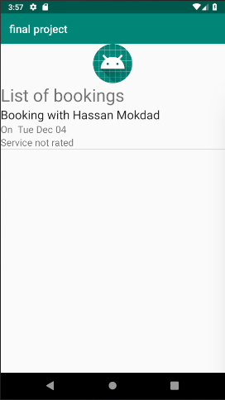 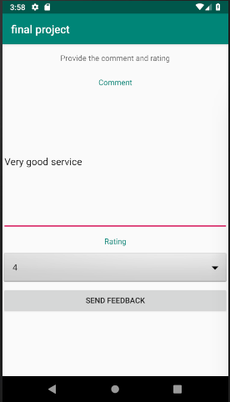

# 

# 5) Lessons Learned

Several lessons were learned during the accomplishment of this application. Before starting to write our code in android studio, it was important for the team to understand the principal functionality of GitHub in order to be able to share our work with every other member of the team.

Once the version control tool has been understood by the whole team, the second important tool learned by the team was the use of the xml tool to design the user interface. Several researches were made to be able to obtain our desired user interface.

The user interface tool being understood, the concepts of object programming learned in class were applied, by representing real world entity such as the service provider and homeowner using classes. The logic between these instances of these classes were implemented using intent representing the current application page.

Finally, using SQLite as the database allowed us to learn a totally new language, writing several queries to create tables, obtain information from the table in the database, insert information in the table of the database and finally delete some row in the database.

Regarding the non-IT tools learned, this project allowed the team to understand the principle of team work and solidarity when a member was not able to accomplish his task.